Day44&45 - Task23 - Jenkins(Part-2)

1.Configure 2 slave machines in Jenkins master.
EC2 & Initial Setup
- Launched three EC2 instances:
  - jenkins-master
  - slave-01
  - slave-02
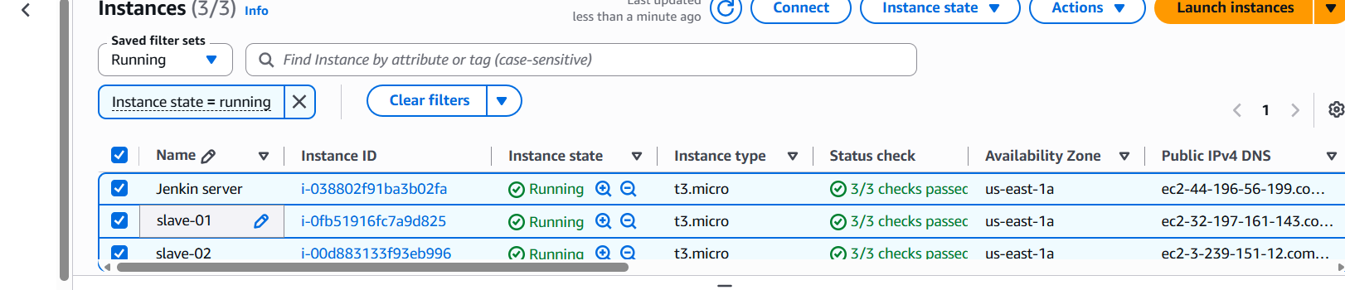
Slave-01 OS Configuration
Logged in to slave-01 as root.
Installed Java:
sudo yum install java-21-amazon-corretto -y
Verified Java installation completed.
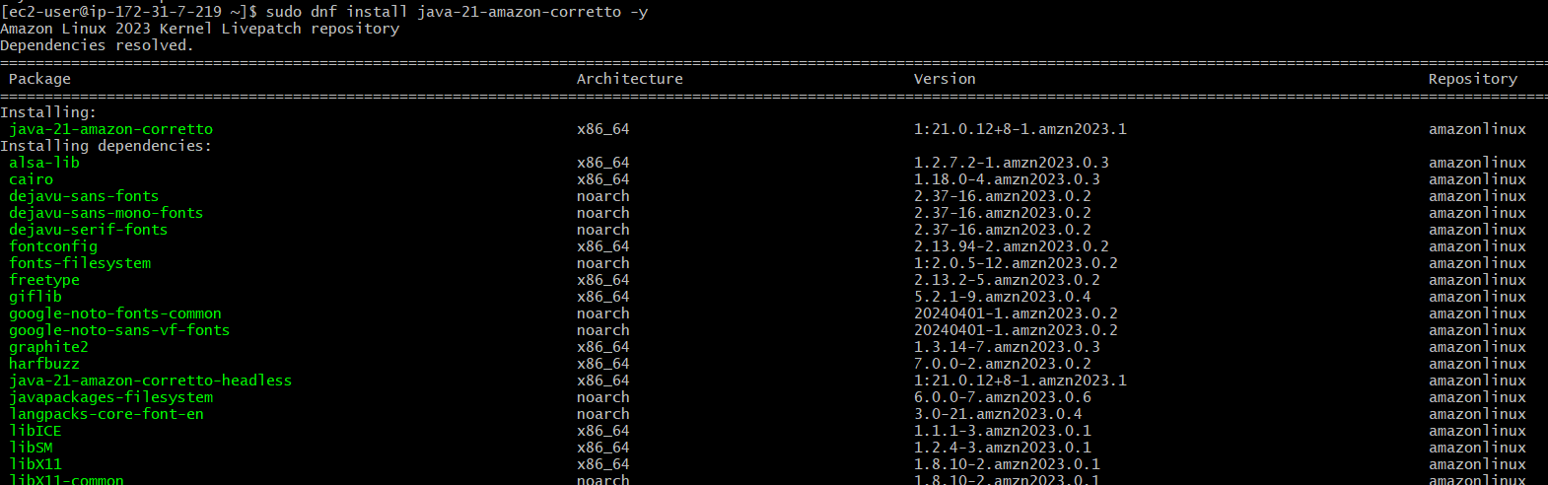
SSH Configuration on Slave-01
Generated SSH key pair:
ssh-keygen
Navigated to SSH directory:
cd ~/.ssh
Added public key to authorized keys:
cat id_rsa.pub >> authorized_keys
Fixed permissions:
chmod 700 authorized_keys
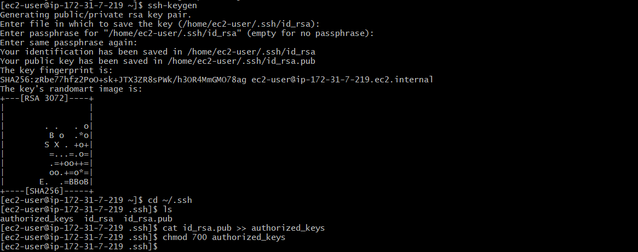
Jenkins Master SSH Trust
Logged in to jenkins-master.
Added slave host key:
ssh-keyscan -H 13.61.10.105 >> /var/lib/jenkins/.ssh/known_hosts
Set correct permissions:
chown jenkins:jenkins /var/lib/jenkins/.ssh/known_hosts
chmod 700 /var/lib/jenkins/.ssh
chmod 600 /var/lib/jenkins/.ssh/known_hosts
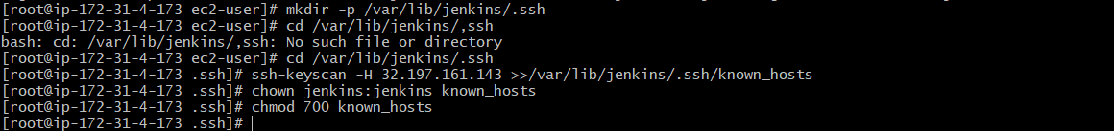
Jenkins Node Creation (slave-01)
Opened Jenkins dashboard.
Navigated to Manage Jenkins → Nodes.
Clicked New Node.
Entered node name: slave-01.
Selected Permanent Agent and created the node.
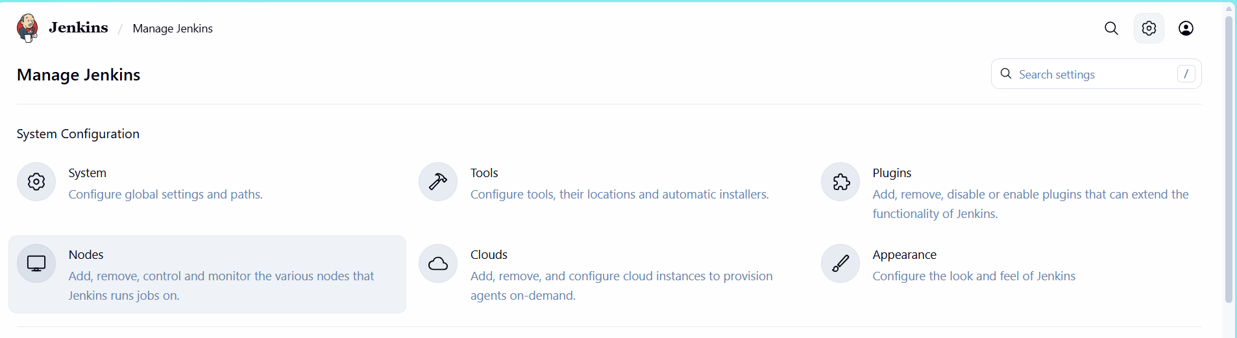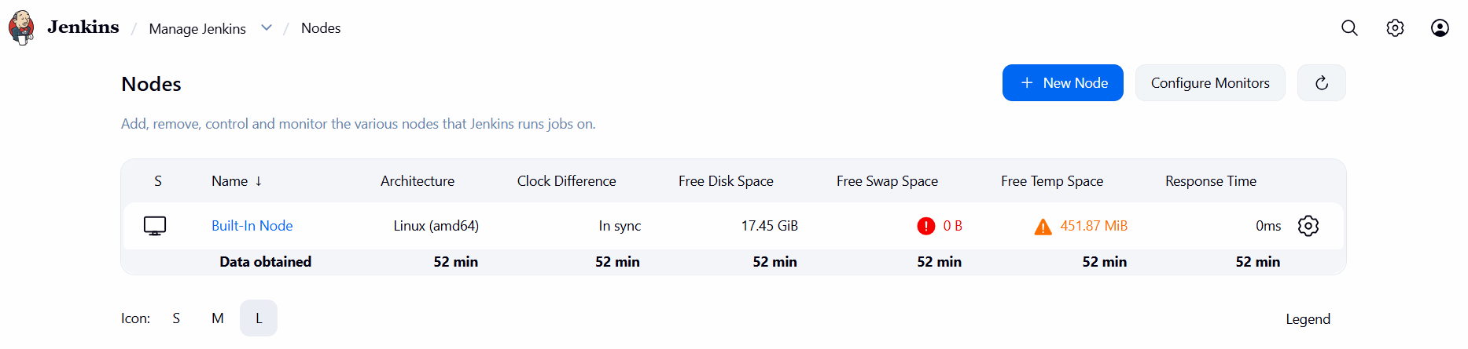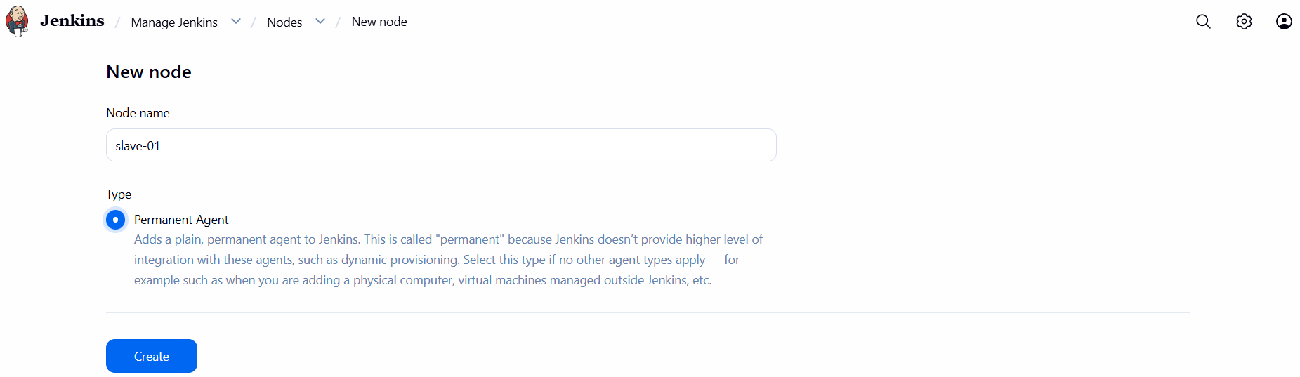
Node Configuration (slave-01)
Set Number of executors to 2.
Initially observed agent offline due to root directory permission issue.
Logged in to slave-01 and created Jenkins workspace:
mkdir -p /home/ec2-user/jenkins
chown -R ec2-user:ec2-user /home/ec2-user/jenkins
Updated Remote root directory in Jenkins to:
/home/ec2-user/jenkins
Added Label:
java
Set Usage to:
Only build jobs with label expressions matching this node
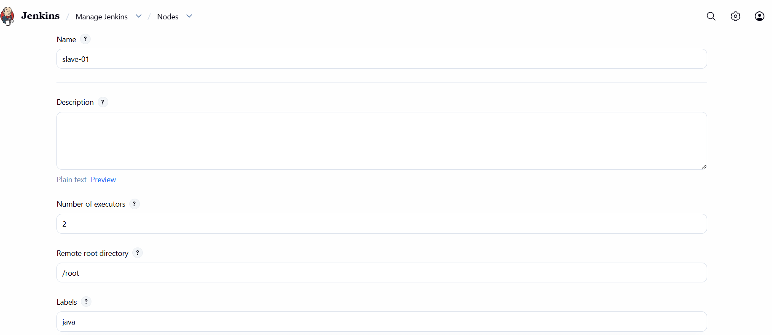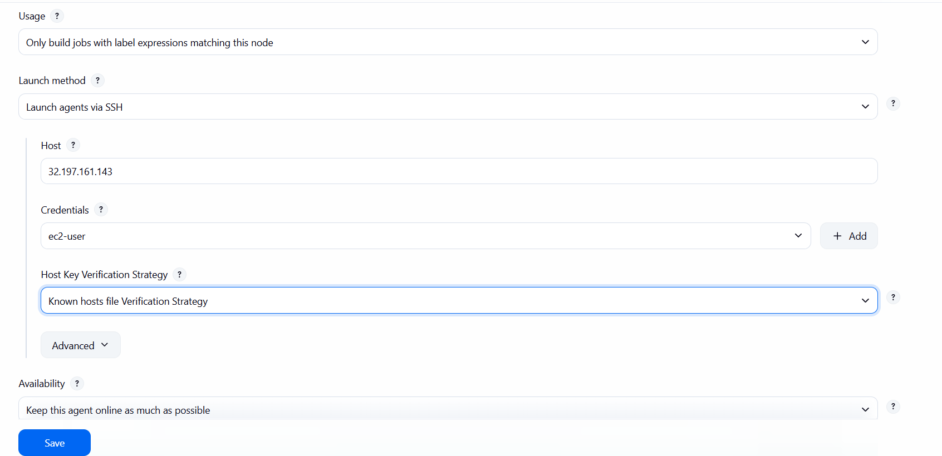
SSH Launch Configuration
Selected Launch agents via SSH.
Entered Host: 13.61.10.105.
Selected SSH credentials (ec2-user).
Chose Known hosts file Verification Strategy.
Saved configuration.
Verified SSH authentication successful in node logs.
Confirmed slave-01 status changed to online.
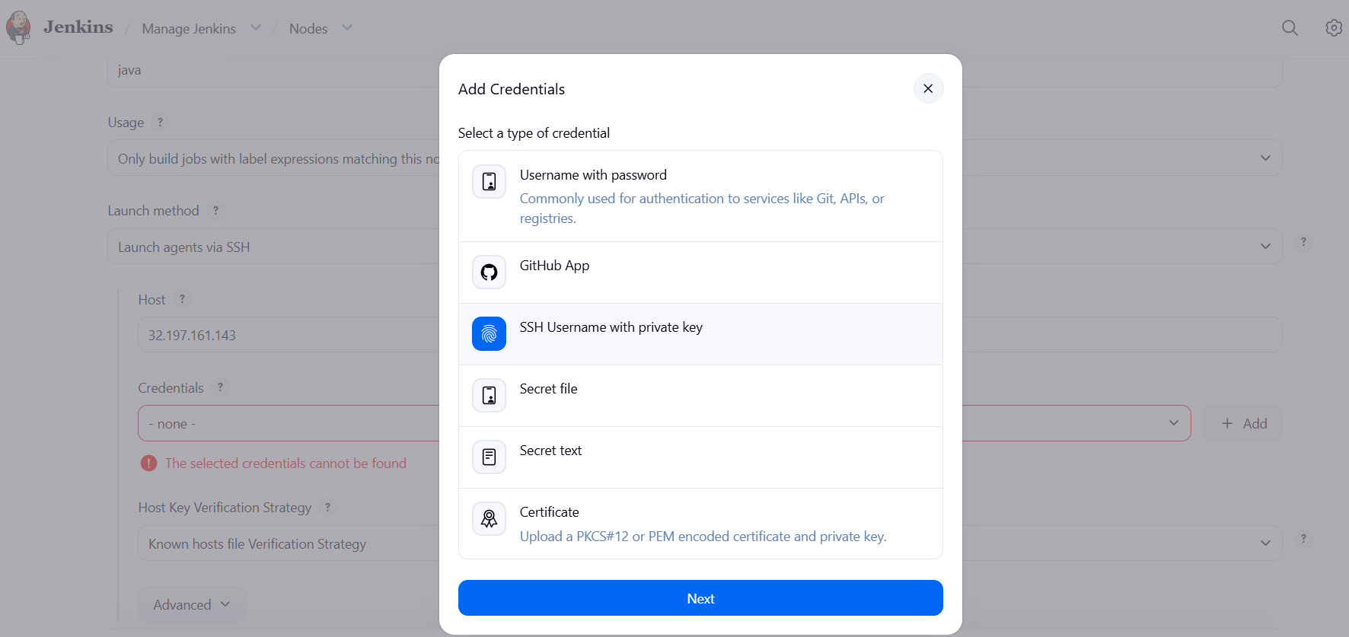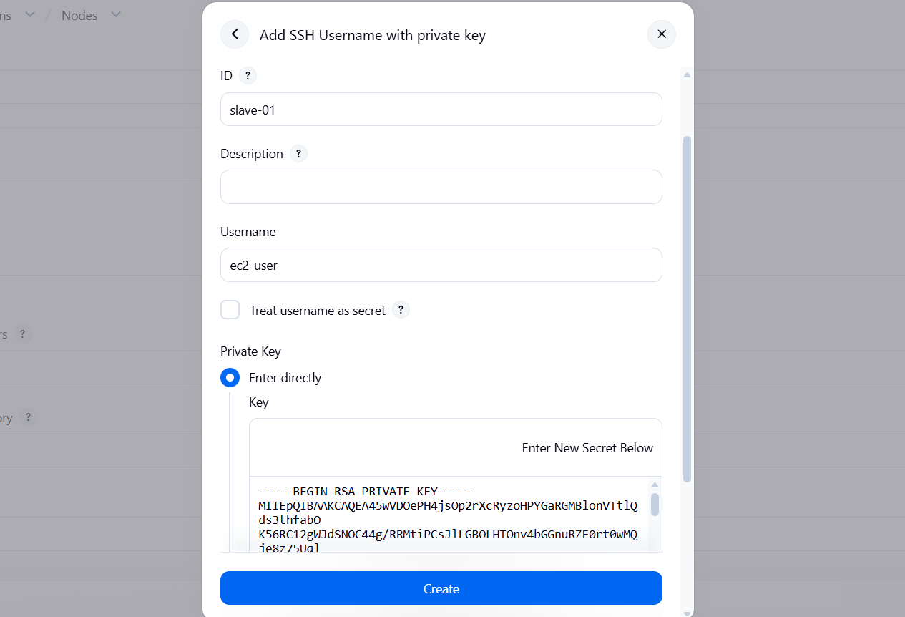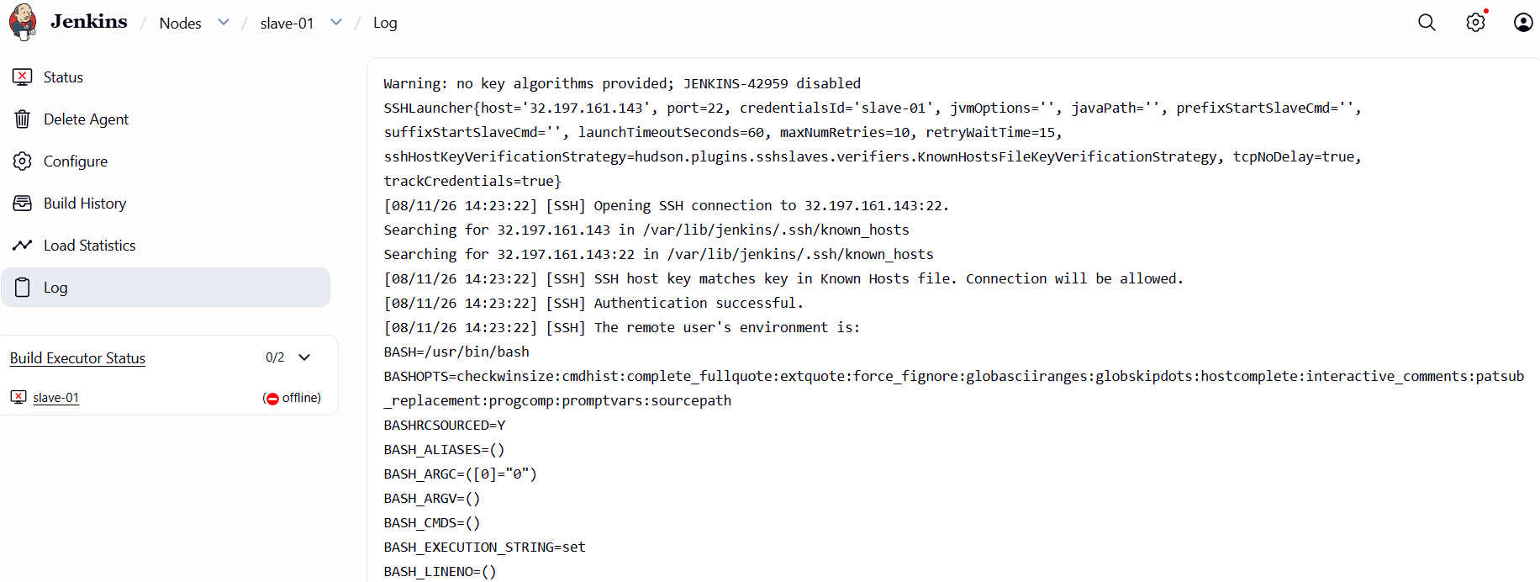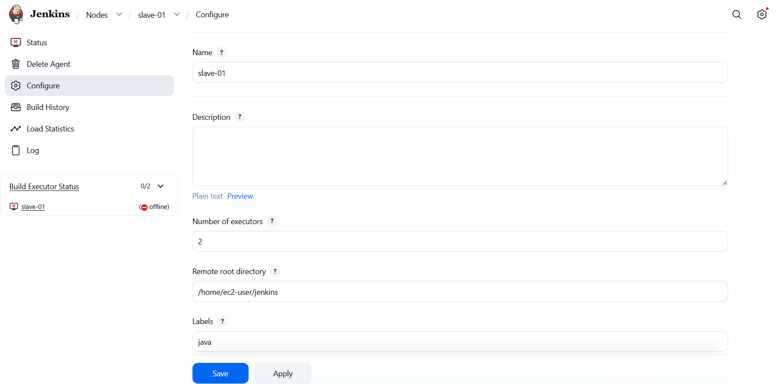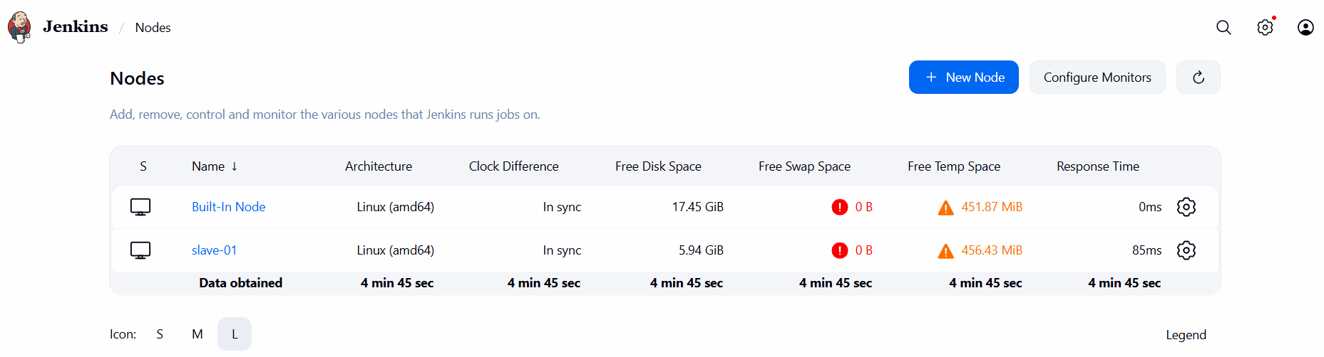
Job Creation & Execution
Clicked New Item.
Entered job name: first_job.
Selected Freestyle project.
Enabled Restrict where this project can be run.
Entered label:
java
Configured Source Code Management → Git.
Entered repository URL:
https://github.com/betawins/Techie_horizon_Login_app.git
Saved the job configuration.
Ran the job.
Verified build executed remotely on slave-01.
Confirmed Git clone successful.
Build finished with SUCCESS.
Final Node Verification
Navigated to Manage Jenkins → Nodes.
Verified:
  - Built-in node → online
  - slave-01 → online with disk & response metrics visible
Slave-02 Configuration
Repeated the same configuration steps (Java install, SSH setup, workspace creation, Jenkins node setup) for slave-02.
Added slave-02 successfully to Jenkins.
Verified both slave-01 and slave-02 are online and available for builds.

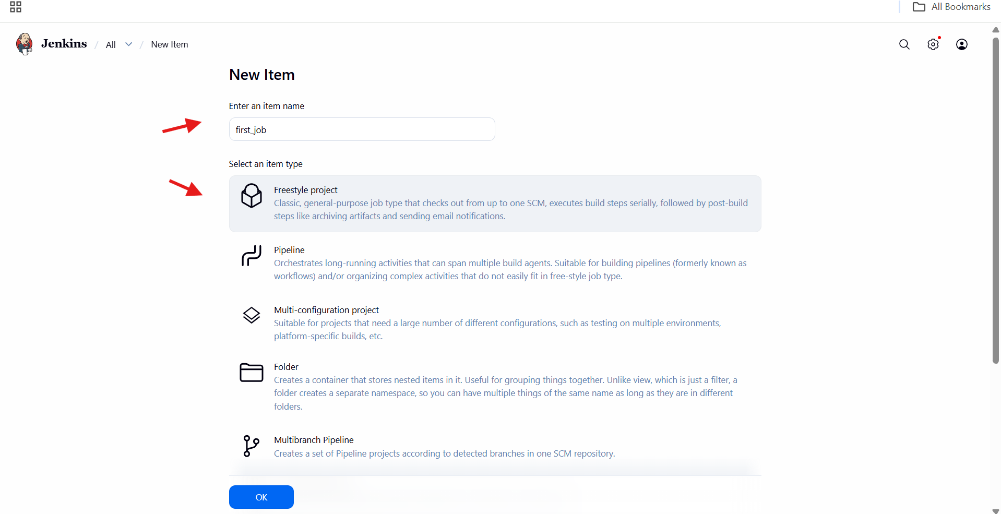

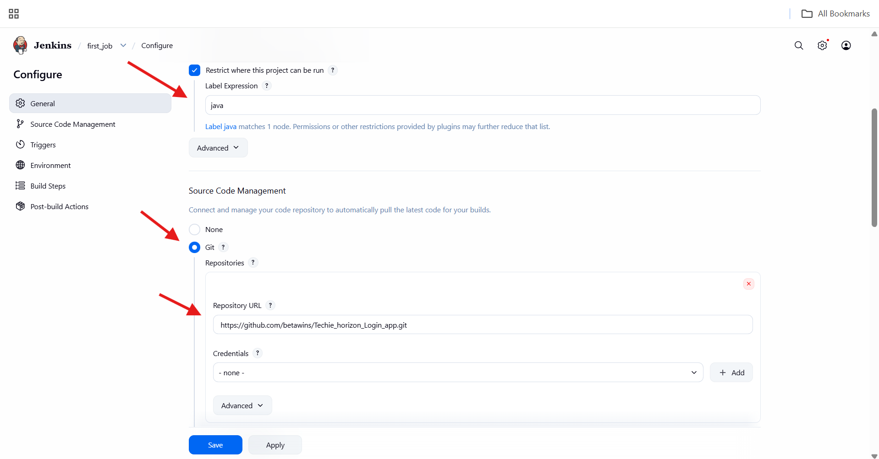

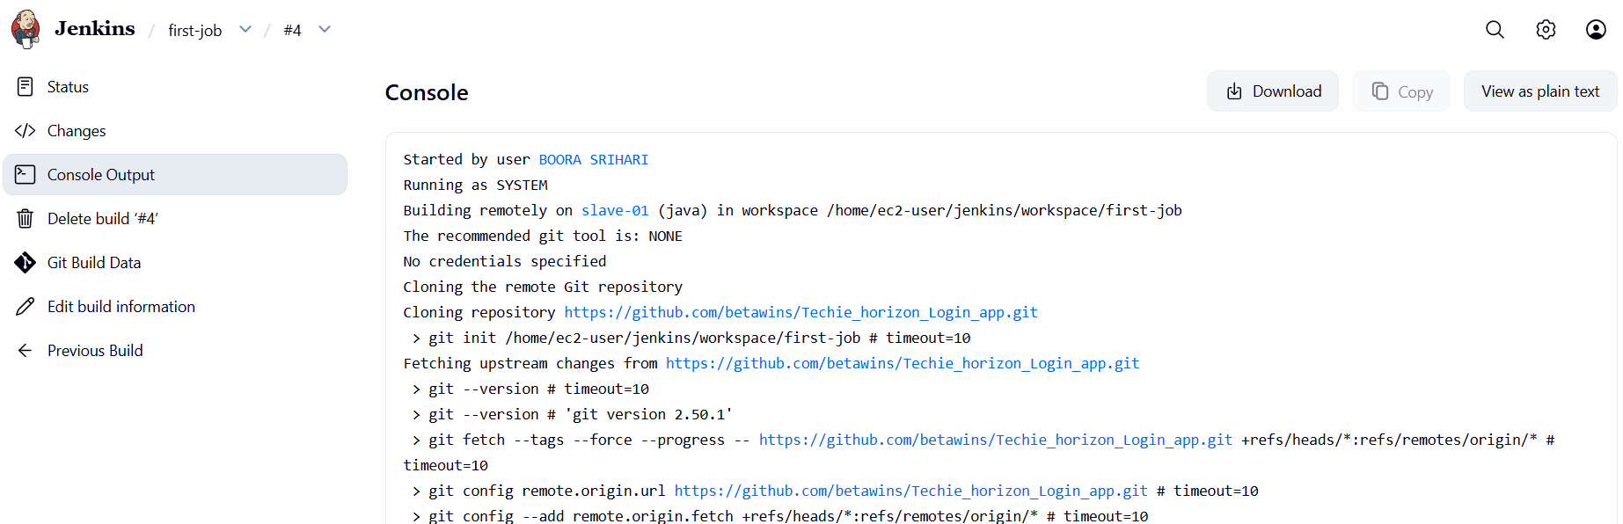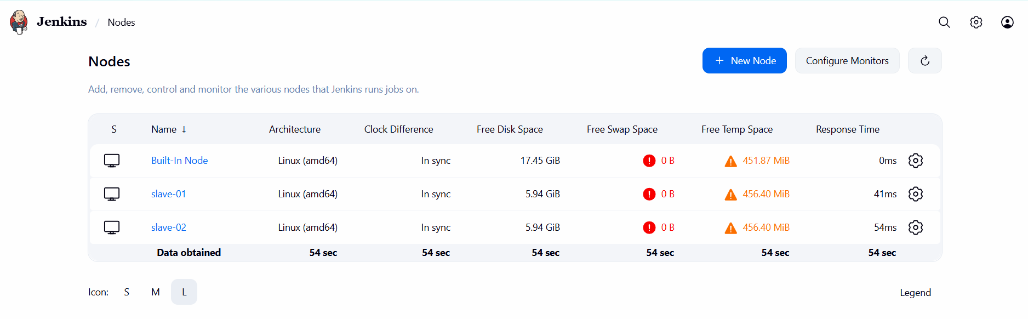

2.Configure webhooks to Jenkins job.
Jenkins Job Configuration
Opened Jenkins and selected the job webhook.
Clicked Configure.
Enabled Restrict where this project can be run.
Entered Label Expression as:
Master

Source Code Management Setup
Selected Git under Source Code Management.
Entered Repository URL:
https://github.com/srihari03-sh/git-practice.git
Left Credentials as none (public repository).
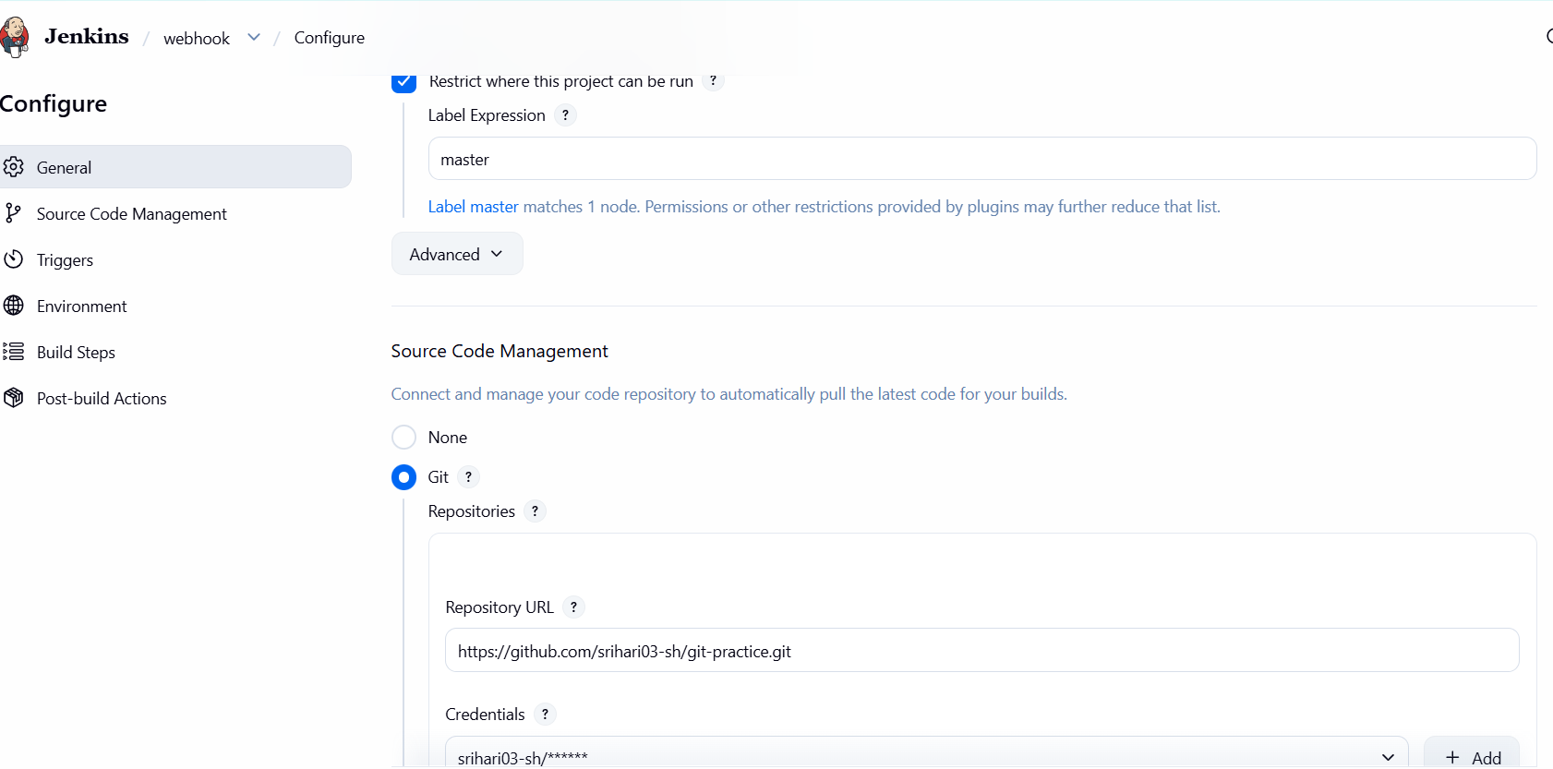
Trigger Configuration
Navigated to Triggers section.
Enabled:
GitHub hook trigger for GITScm pollin
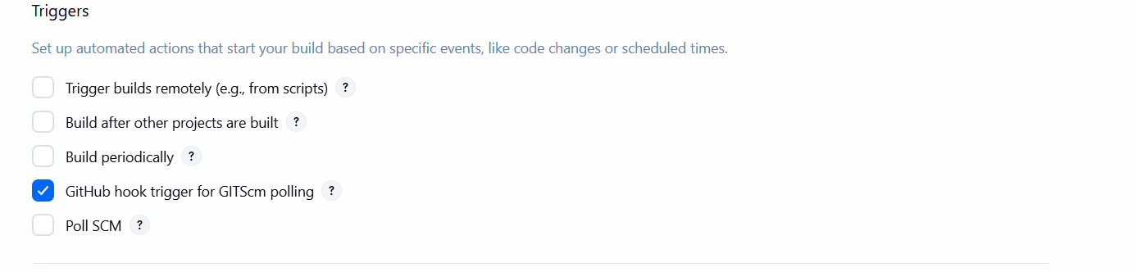
Build Step Configuration
Scrolled to Build Steps.
Selected Execute shell.
Added command:
sleep 15
Clicked Save.
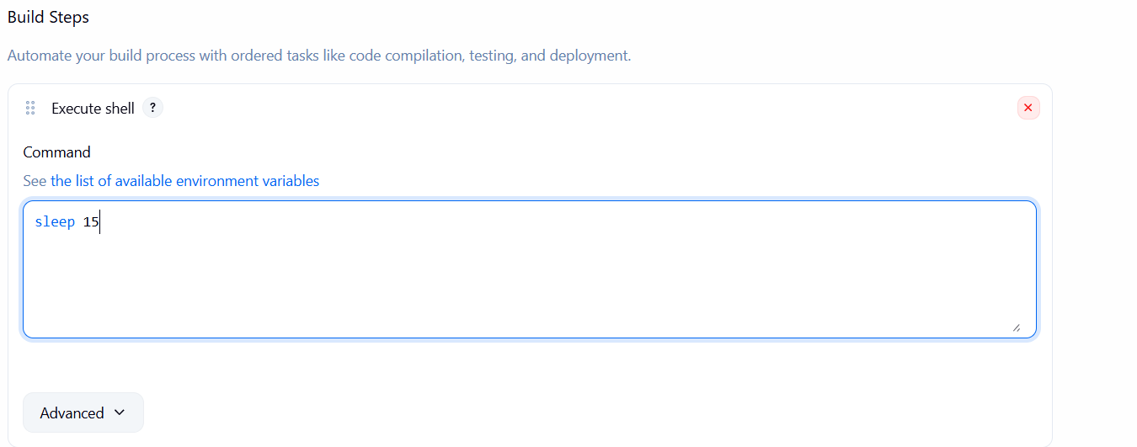
GitHub Webhook Creation
Opened GitHub repository:
https://github.com/srihari03-sh/git-practice
Navigated to:
Settings → Webhooks → Add webhook
Entered Payload URL:
http://13.53.212.231:8081/github-webhook/
Selected Content type:
application/json
Kept Secret empty.
Selected:

Send me everything
Enabled Active.
Clicked Add webhook.
Verified webhook added successfully 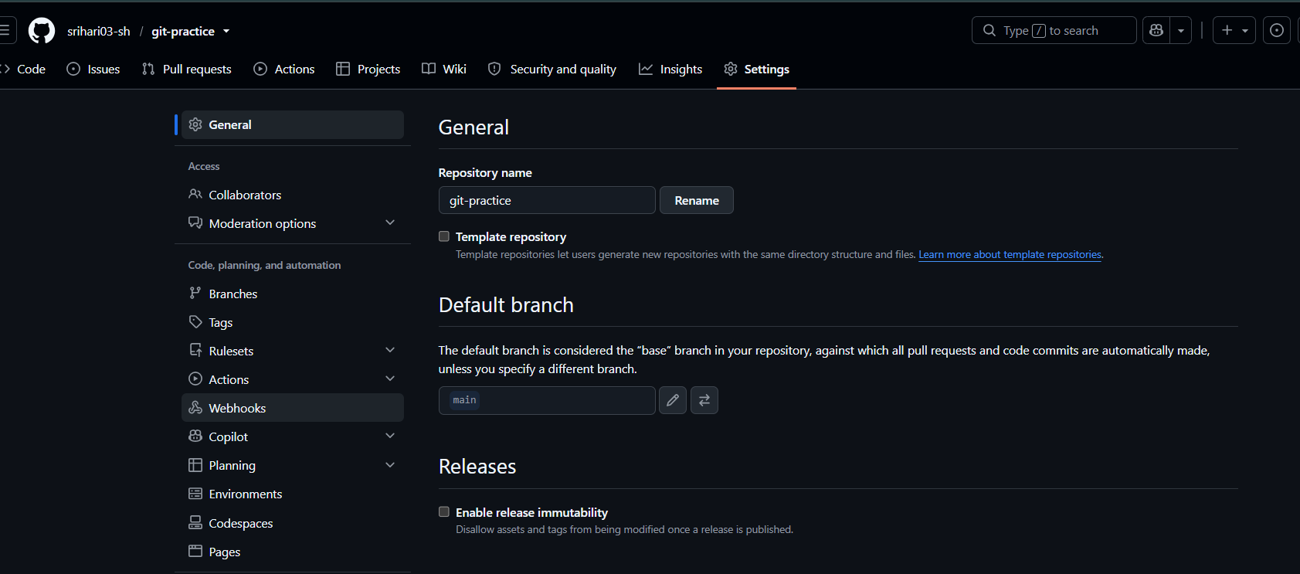 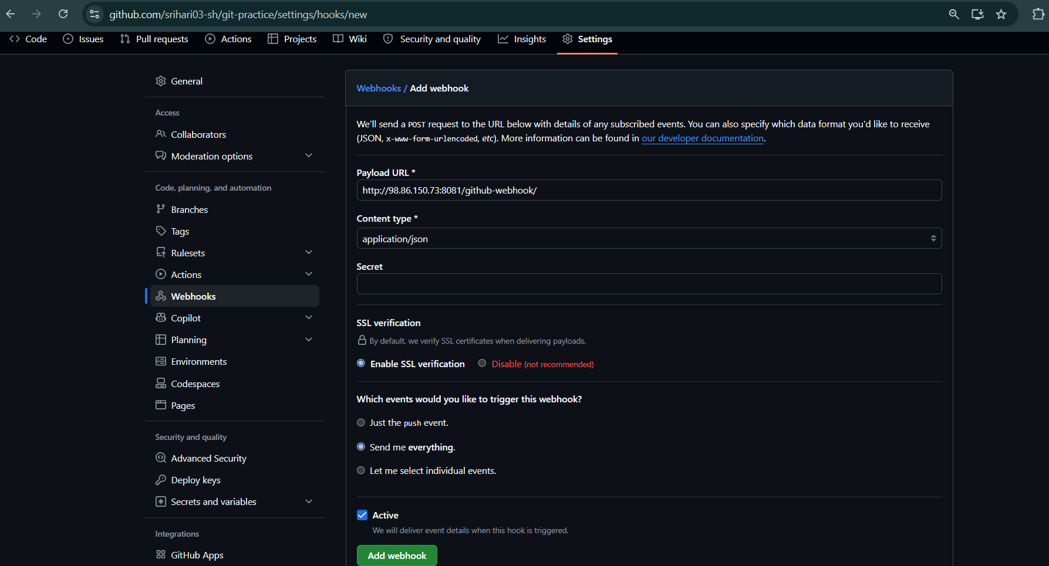
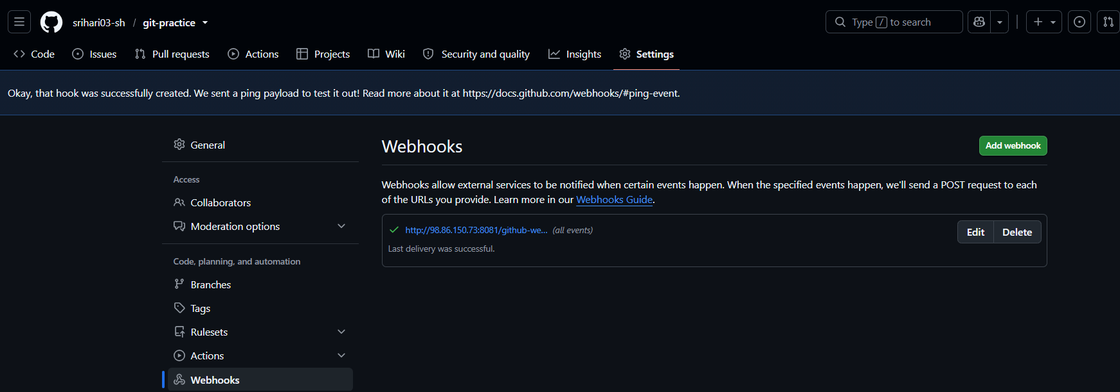
Repository Change
Opened README.md in the repository.
Edited the file.
Committed changes to the master branch.
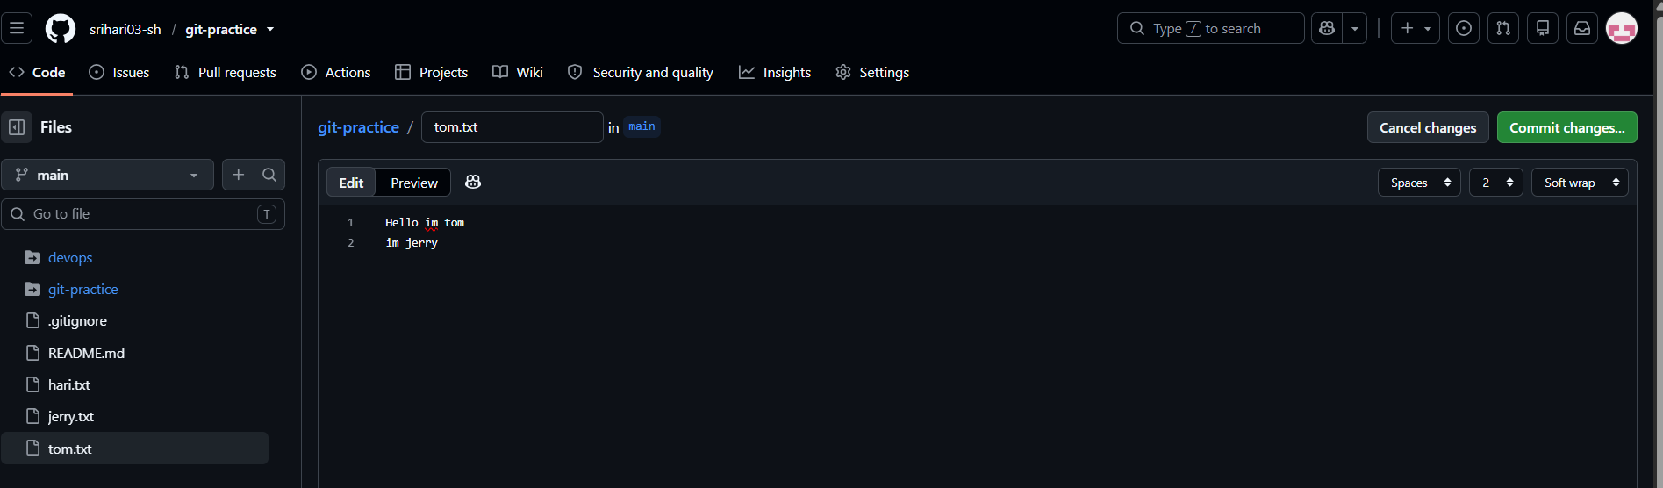
Jenkins Build Execution
GitHub webhook triggered Jenkins automatically.
Jenkins job started without manual build.
Build executed on Built-in (master) node.
Jenkins cloned the repository successfully.
Shell command executed.
Console output showed:
job triggered successfully
Build finished with SUCCESS status.
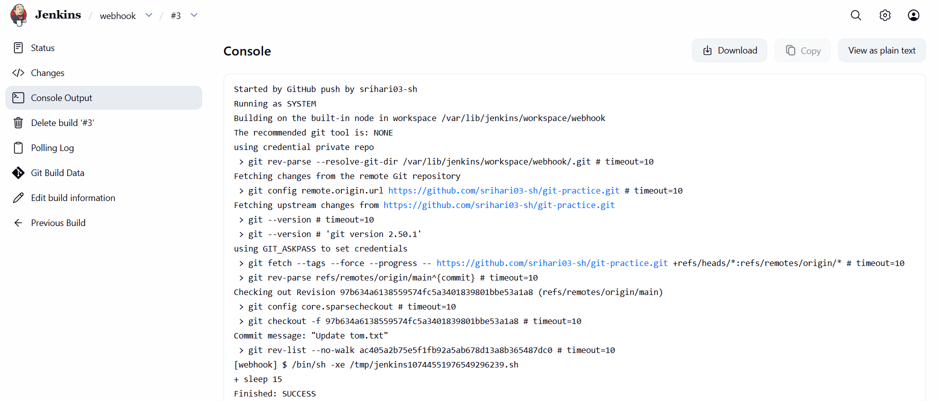

3.Configure poll scm and build periodical options in Jenkins job.
Steps Performed – Jenkins Periodic Build (first_job)
Job General Configuration
Opened Jenkins and selected first_job.
Clicked Configure.
Added Description:
added build periodically
Enabled Restrict where this project can be run.
Set Label Expression to:
master
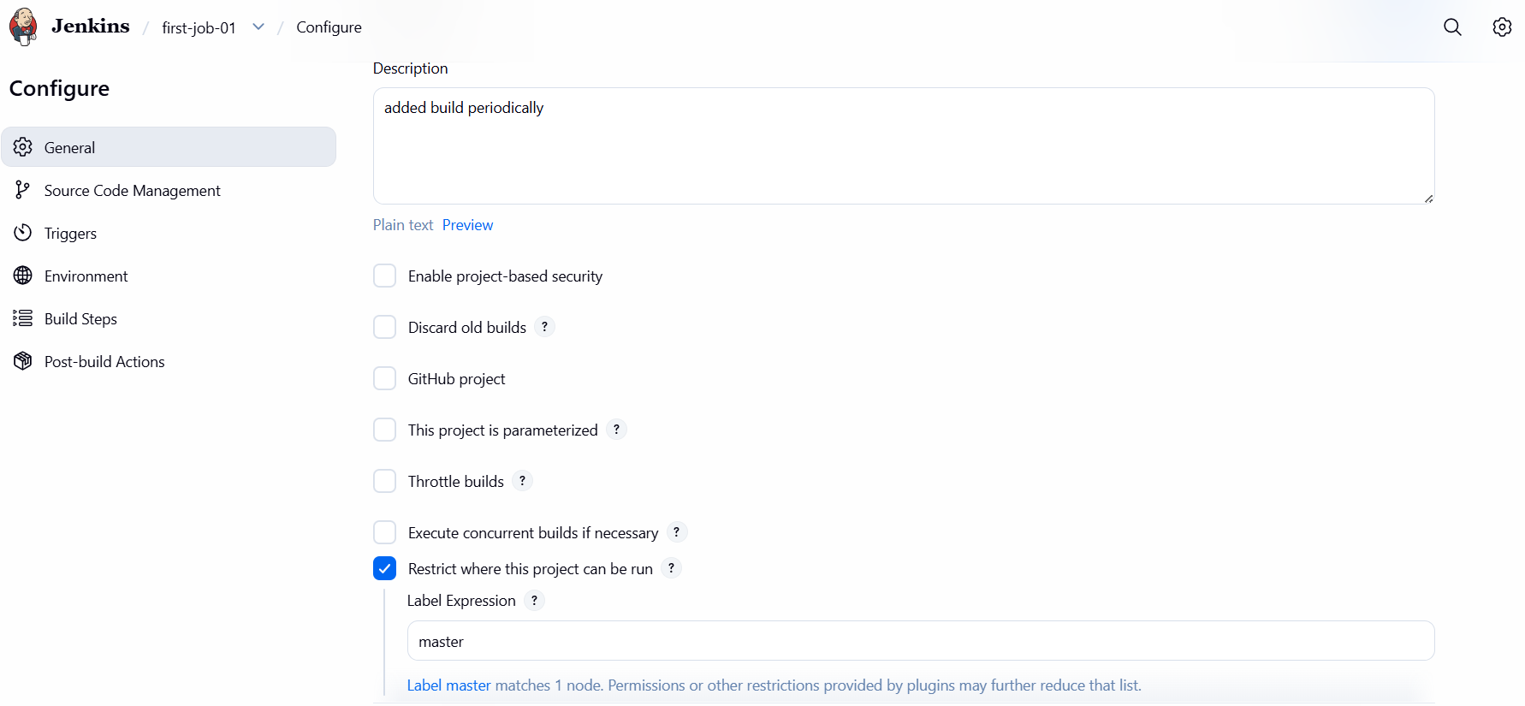

Source Code Management
Navigated to Source Code Management.
Selected Git.
Entered Repository URL:
https://github.com/srihari03-sh/git-practice.git
Left Credentials as none.
Set Branch Specifier to:
*/main
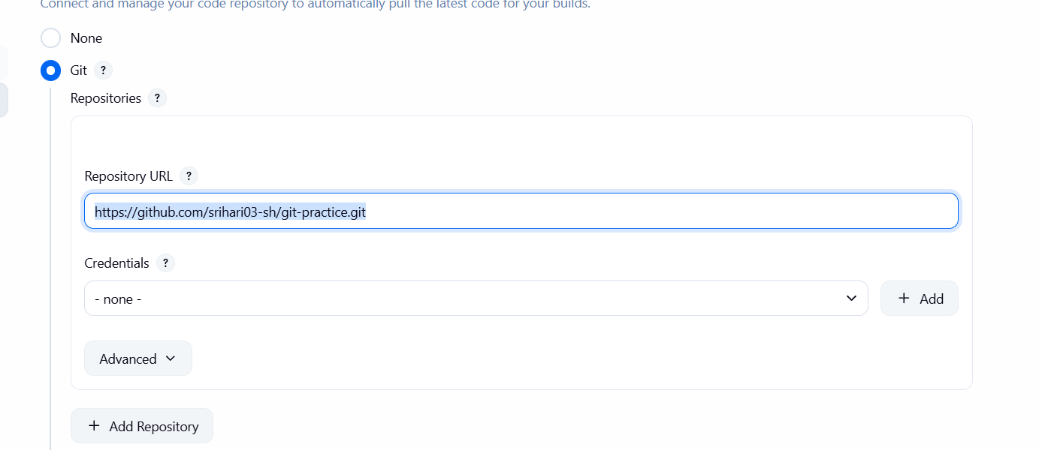
Trigger – Build Periodically
Opened Triggers section.
Enabled Build periodically.
Entered schedule:
* * * * *
Saved the job configuration.
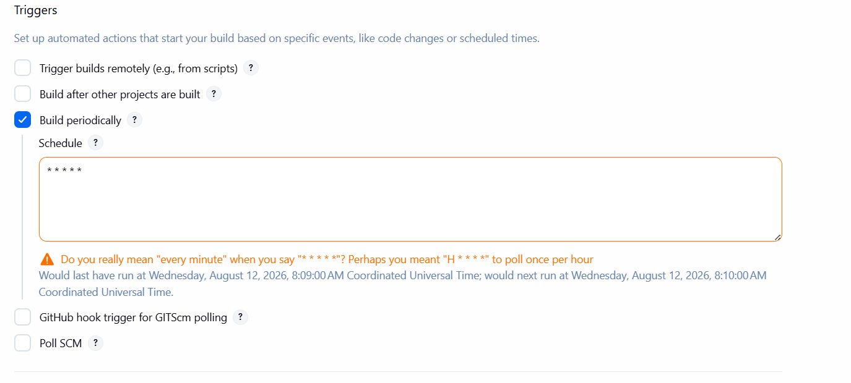
Jenkins Built Execution
Jenkins automatically triggered builds based on the schedule.
Multiple builds appeared in Build History.
Selected a build and opened Console Output.
Verified message:
Started by timer
Jenkins fetched the latest code from GitHub.
Build completed with SUCCESS status.
SCM Trigger Verification
Returned to Triggers configuration.
Enabled Poll SCM.
Entered schedule:
* * * * *
Saved configuration.
GitHub Repository Change
Opened GitHub repository devops-hub.
Edited README.md.
Added content to the file.
Committed changes to master branch.
Jenkins SCM-Based Build
Jenkins detected SCM change.
New build appeared with status Started by an SCM change.
Opened Console Output.
Verified Git fetch and checkout steps.
Build completed with SUCCESS.
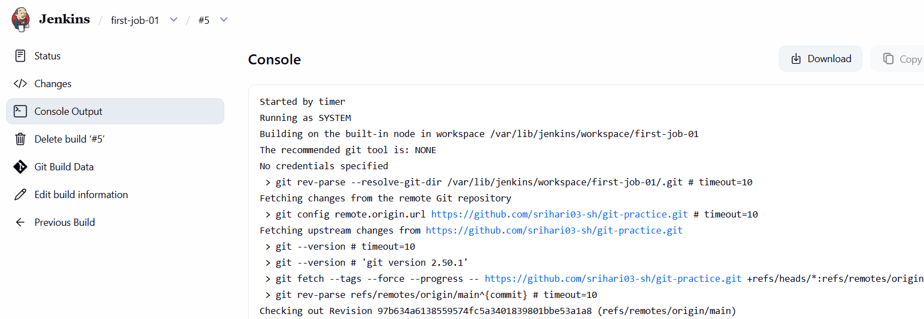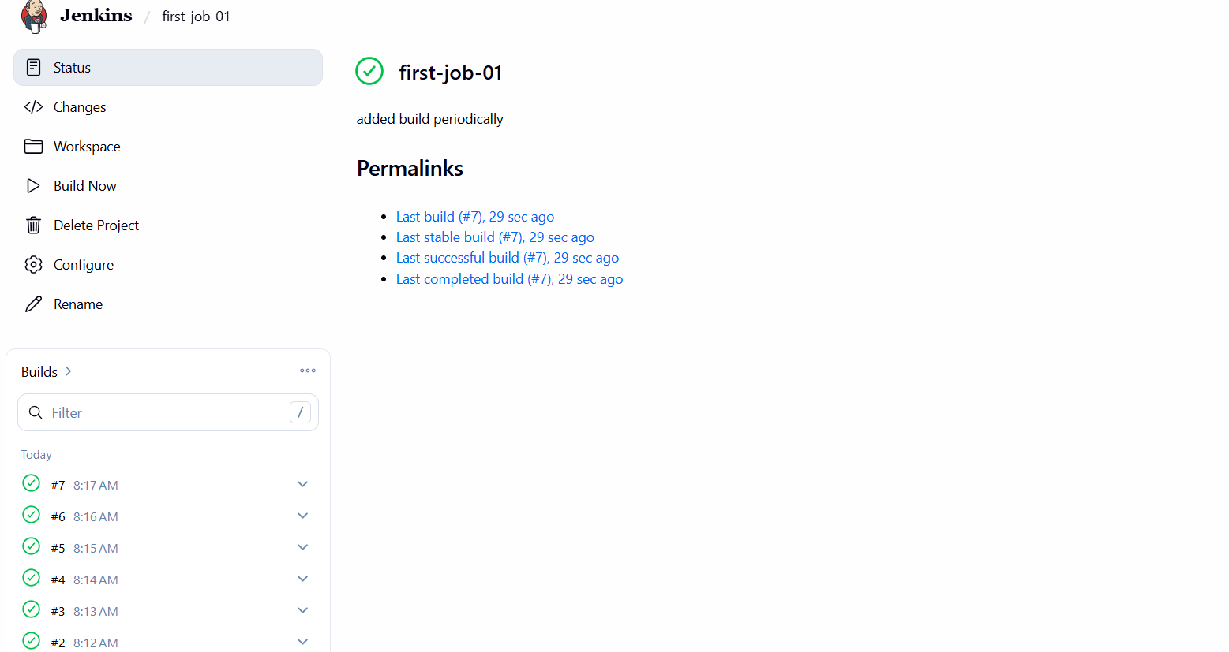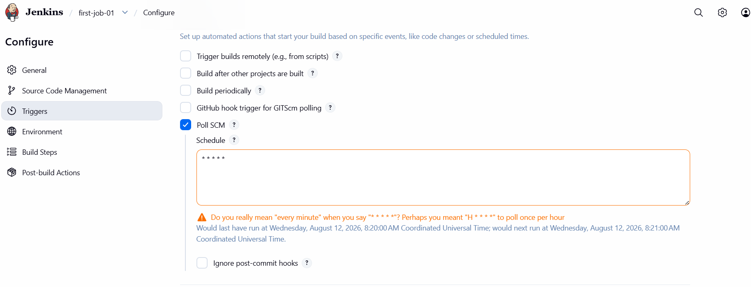
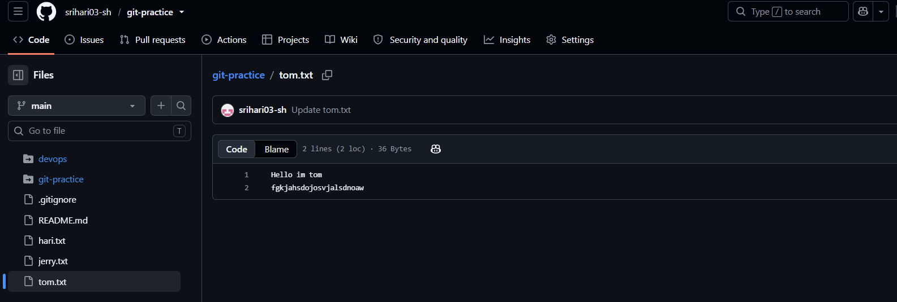

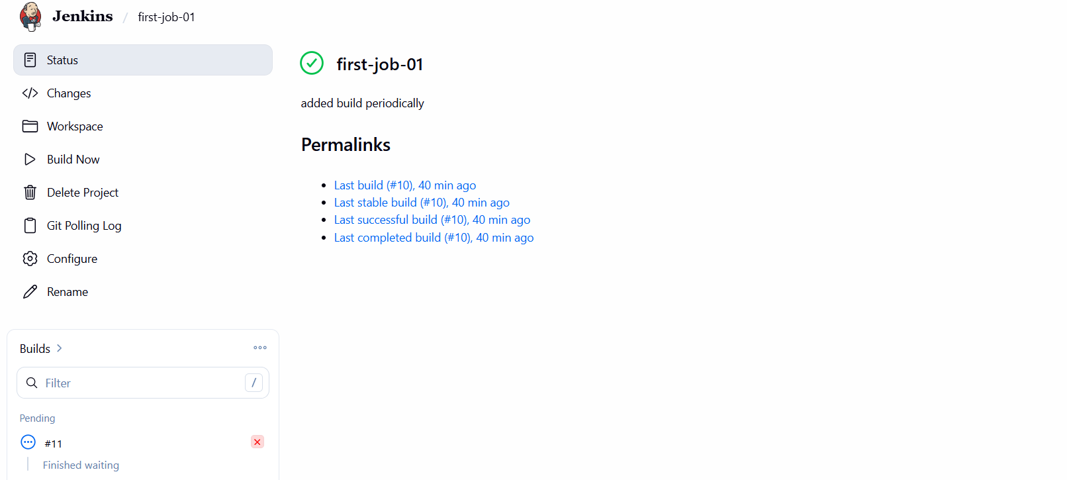

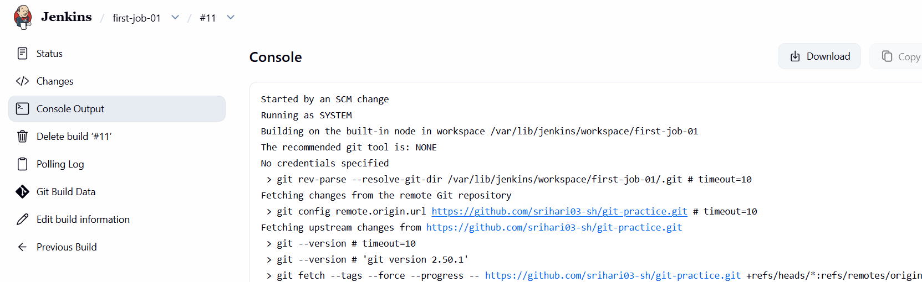

4. Take backup of Jenkins server by using bash script.
Steps Performed – Jenkins Backup Script
Objective
To take a backup of the Jenkins Master server using a Bash script and securely transfer the backup file to Jenkins Slave/Agent servers using SCP.
Environment
- Jenkins Master: EC2 instance
- Jenkins Slave-01: EC2 instance
- Jenkins Slave-02: EC2 instance
- Jenkins Home Directory: /var/lib/jenkins
- Backup Directory on Master: /backup/jenkins
- Backup Format: .tar.gz

Step 1: Create the Jenkins Backup Script
Created a Bash script to back up the Jenkins Home directory.
Created the script file:
sudo vi /opt/scripts/jenkins_backup.sh
Added the following content:
#!/bin/bash

# Jenkins home directory
JENKINS_HOME="/var/lib/jenkins"

# Backup directory
BACKUP_DIR="/backup/jenkins"

# Date variable
DATE=$(date +"%Y-%m-%d_%H-%M-%S")

# Create backup directory
mkdir -p "$BACKUP_DIR"

# Take Jenkins backup
tar -czvf "$BACKUP_DIR/jenkins_backup_$DATE.tar.gz" \
--exclude="$JENKINS_HOME/workspace" \
--exclude="$JENKINS_HOME/logs" \
"$JENKINS_HOME"

echo "Jenkins backup completed successfully!"
echo "Backup file: $BACKUP_DIR/jenkins_backup_$DATE.tar.gz"
Explanation
- JENKINS_HOME → Jenkins data directory.
- BACKUP_DIR → Location where the backup will be stored.
- DATE → Adds the current date and time to the backup filename.
- mkdir -p → Creates the backup directory if it does not exist.
- tar -czvf → Compresses the Jenkins directory into a .tar.gz file.
- --exclude → Excludes workspace and log directories from the backup.

Step 2: Give Execute Permission
After saving the script, provided execute permission:
sudo chmod +x /opt/scripts/jenkins_backup.sh
Verified the script:
ls -l /opt/scripts/jenkins_backup.sh

Step 3: Execute the Backup Script
Ran the script:
sudo /opt/scripts/jenkins_backup.sh
The script completed successfully and generated a backup file similar to:
Jenkins backup completed successfully!
Backup file: /backup/jenkins/jenkins_backup_2026-08-12_09-34-50.tar.gz

Step 4: Verify the Backup File
Checked the backup directory:
ls -lh /backup/jenkins/
Output:
jenkins_backup_2026-08-12_09-34-50.tar.gz
This confirmed that the Jenkins backup was successfully created.

Transfer Jenkins Backup to Slave-01
Step 5: Configure SSH Authentication
To transfer the backup from the Jenkins Master to Slave-01 using SCP, SSH authentication between the servers was configured.
On the Jenkins Master, generated an SSH key pair:
ssh-keygen
Pressed Enter to accept the default location:
/home/ec2-user/.ssh/id_rsa
The following files were created:
/home/ec2-user/.ssh/id_rsa
/home/ec2-user/.ssh/id_rsa.pub
- id_rsa → Private key
- id_rsa.pub → Public key

Step 6: Add Master Public Key to Slave-01
Displayed the public key on the Master:
cat ~/.ssh/id_rsa.pub
Copied the complete public key.
Logged into Slave-01 using its EC2 access method and created the SSH directory:
mkdir -p ~/.ssh
chmod 700 ~/.ssh
Opened the authorized keys file:
vi ~/.ssh/authorized_keys
Pasted the Master public key into the file.
Then set the correct permission:
chmod 600 ~/.ssh/authorized_keys

Step 7: Test Passwordless SSH
From the Jenkins Master, tested the connection:
ssh ec2-user@44.222.162.151
The connection was successful without requiring the original EC2 private key each time.
This confirmed that passwordless SSH authentication between Master and Slave-01 was working.

Transfer the Backup Using SCP
Step 8: Create Backup Directory on Slave-01
Initially, SCP returned the following error:
scp: dest open "/backup/jenkins/": No such file or directory
This occurred because the destination directory did not exist on Slave-01.
Logged into Slave-01:
ssh ec2-user@44.222.162.151
Created the directory:
sudo mkdir -p /backup/jenkins
Changed ownership so that ec2-user could write to the directory:
sudo chown -R ec2-user:ec2-user /backup/jenkins
Verified:
ls -ld /backup/jenkins

Step 9: Copy Backup from Master to Slave-01
Returned to the Jenkins Master and executed:
scp /backup/jenkins/jenkins_backup_2026-08-12_09-34-50.tar.gz \
ec2-user@44.222.162.151:/backup/jenkins/
The backup file was transferred from the Jenkins Master to Slave-01.
SCP Explanation
Source:
/backup/jenkins/jenkins_backup_2026-08-12_09-34-50.tar.gz

Destination:
ec2-user@44.222.162.151:/backup/jenkins/

Step 10: Verify Backup on Slave-01
Logged into Slave-01:
ssh ec2-user@44.222.162.151
Checked the backup directory:
ls -lh /backup/jenkins/
The backup file was present:
jenkins_backup_2026-08-12_09-34-50.tar.gz
This confirmed that the Jenkins backup was successfully transferred from the Master to Slave-01.

Important SCP Error and Resolution
Initially, the following command was used incorrectly:
scp -i jenkins_backup_2026-08-12_09-34-50.tar.gz ec2-user@44.222.162.151:~
This was incorrect because -i is used to specify an SSH private key, not the backup file.
The correct approach was to configure SSH authentication and then use:
scp /backup/jenkins/jenkins_backup_2026-08-12_09-34-50.tar.gz \
ec2-user@44.222.162.151:/backup/jenkins/

Final Result
The Jenkins backup process was successfully configured:
- Jenkins Home directory was identified.
- Bash backup script was created.
- Execute permission was provided.
- Jenkins backup was generated as a .tar.gz file.
- Backup file was verified on the Master.
- SSH key-based authentication was configured between Master and Slave-01.
- Backup directory was created on Slave-01.
- Backup was transferred using SCP.
- Backup file was verified on Slave-01.
Next step: Repeat the same SCP process for Slave-02 so that the Jenkins backup is stored on both slave servers.
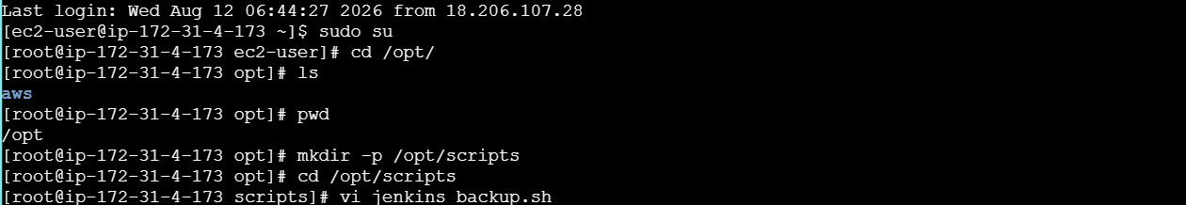
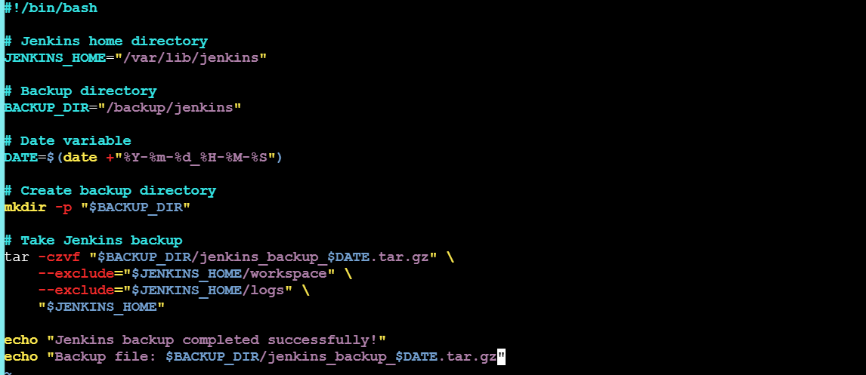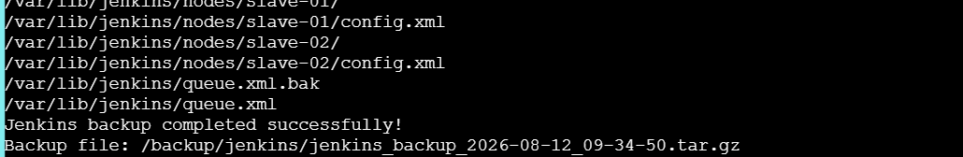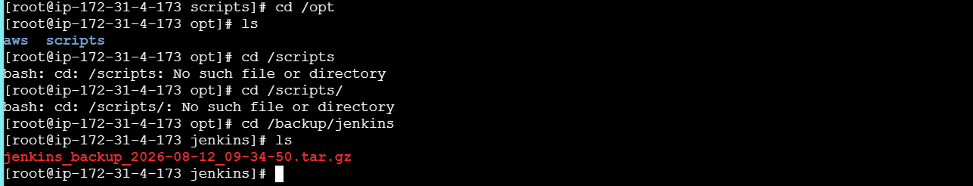

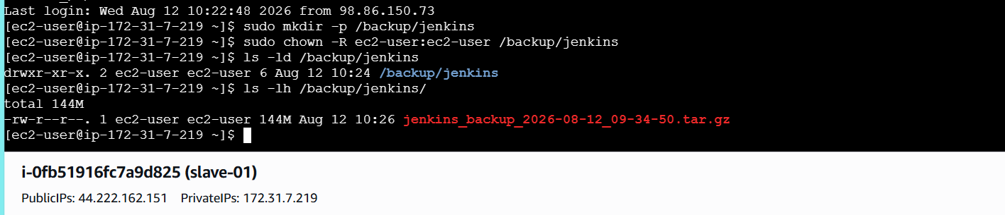

5. Take backup of Jenkins using thin backup plugin.
Steps Performed – Jenkins ThinBackup Plugin Backup
Install ThinBackup Plugin
Opened Jenkins UI.
Navigated to:
Manage Jenkins → Plugins → Available plugins
Searched for ThinBackup.
Selected the ThinBackup plugin.
Clicked Install.
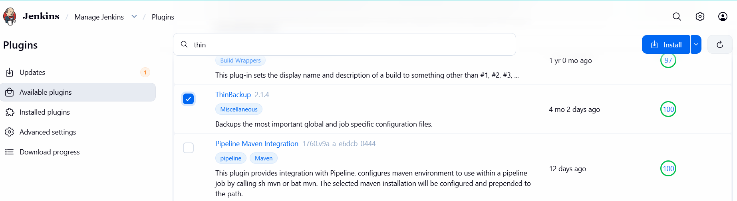
Plugin Installation Verification
Opened Download progress page.
Verified:
  - Internet connectivity check → Success
  - Update center connectivity → Success
  - ThinBackup plugin → Installed successfully
Clicked Go back to the top page.
Access ThinBackup
Navigated to:
Manage Jenkins → ThinBackup
Confirmed ThinBackup page loaded successfully.
Observed available options:
- Backup now
- Restore
Prepare Backup Directory on Server
Logged in to Jenkins server as root.
Created backup directory:
mkdir -p /opt/jenkins-backup
Changed ownership to Jenkins user:
chown -R jenkins:jenkins /opt/jenkins-backup
Set permissions:
chmod 755 /opt/jenkins-backup
Verify Backup File
Listed contents of backup directory:
ls -ltr /opt/jenkins-backup
Verified backup archive exists:
jenkins_backup_2025-12-25_13-57.tar.gz

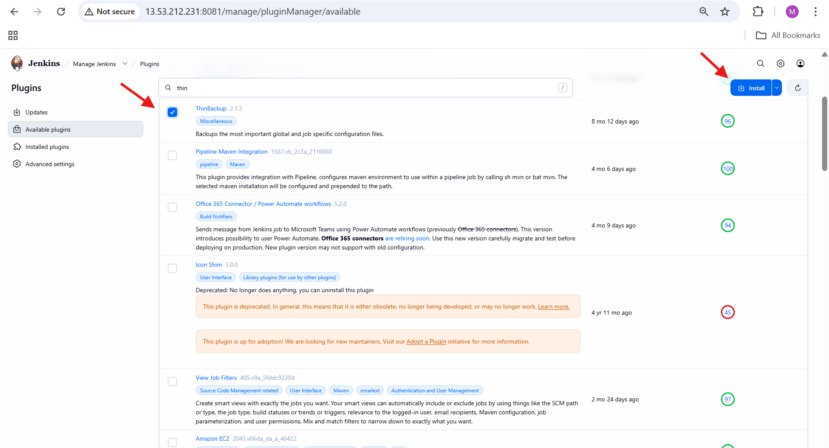

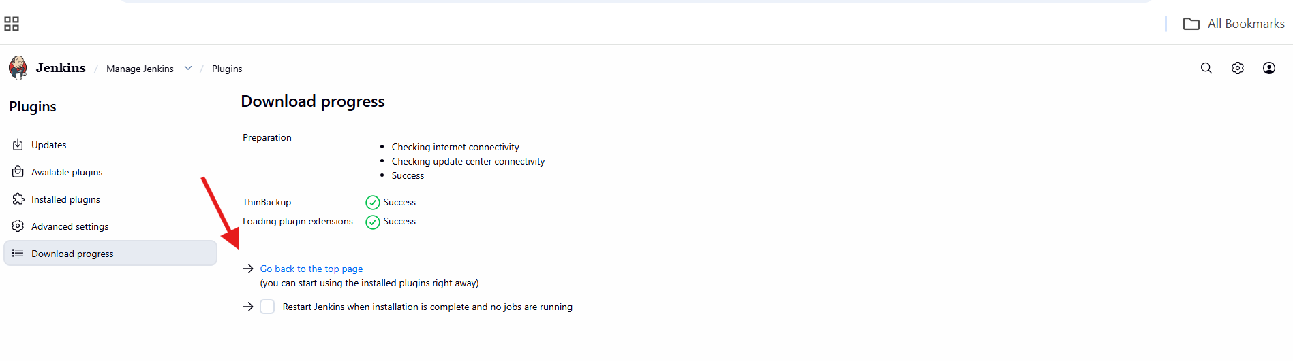

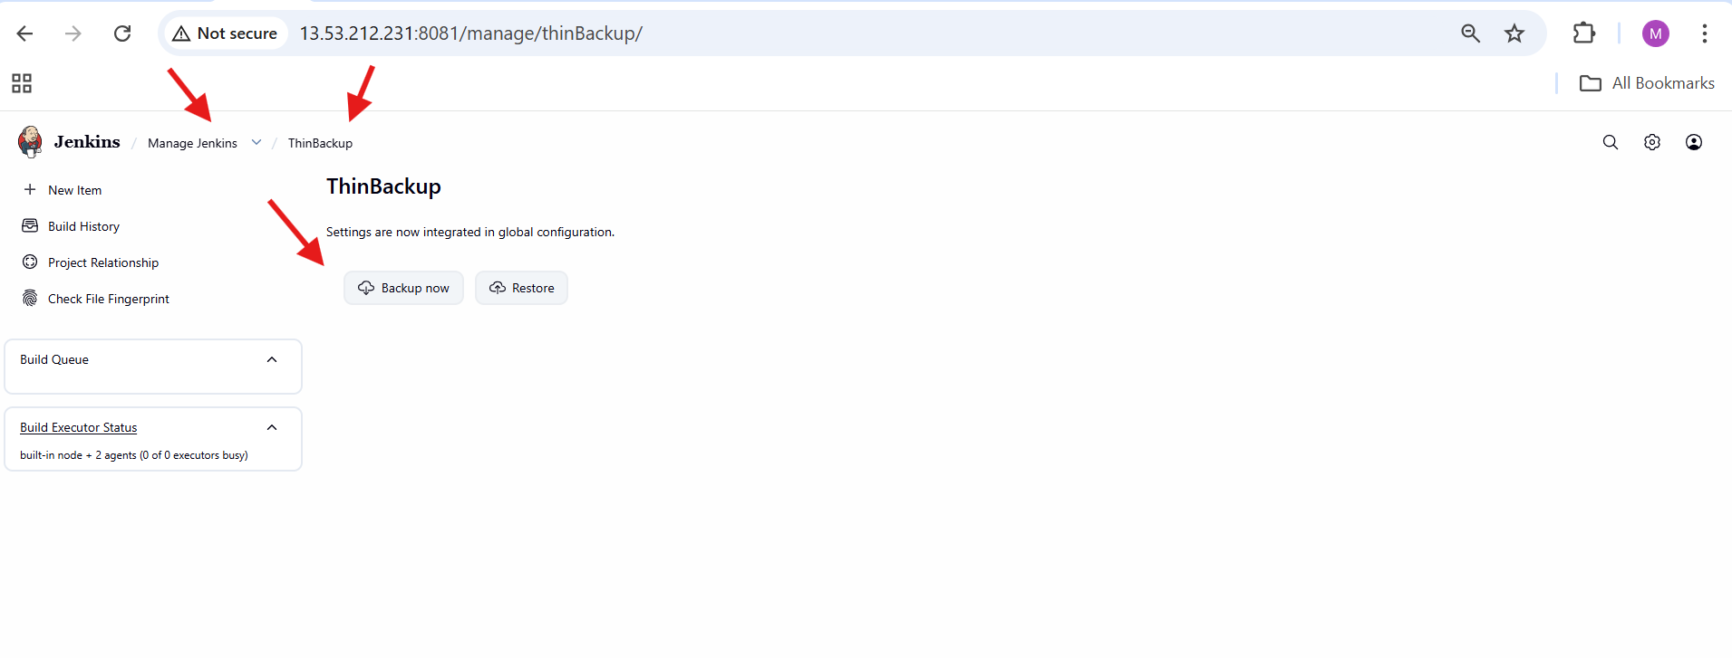
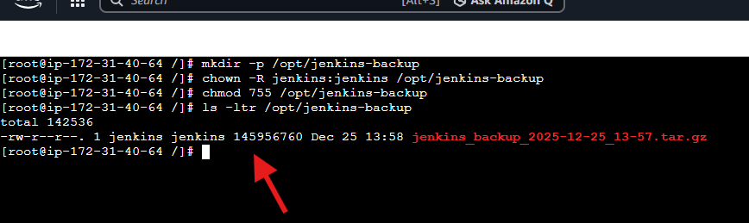

6. Setup a new Jenkins server and dump the backup taken in task4.
On Jenkins Master (Old Server)
Logged in to jenkins-master EC2 instance.
Navigated to /opt:
cd /opt
Listed directories and verified jenkins-backup exists.
Moved into backup directory:
cd jenkins-backup
Verified Jenkins backup file is present:
jenkins_backup_2025-12-25_13-57.tar.gz
On Backup EC2 Instance (New Server)
Logged in to backup EC2 instance.
Added Jenkins repository:
wget -O /etc/yum.repos.d/jenkins.repo https://pkg.jenkins.io/redhat/jenkins.repo
Imported Jenkins GPG key:
rpm --import https://pkg.jenkins.io/redhat-stable/jenkins.io-2023.key
Installed Java:
yum install java-17-amazon-corretto -y
Installed Jenkins:
yum install jenkins -y
Started Jenkins service:
systemctl start jenkins
Verified Jenkins service status:
systemctl status jenkins
Access Jenkins on Backup Server
Opened browser and accessed Jenkins:
http://56.228.32.222:8080
Confirmed Jenkins UI loaded successfully.
Transfer Backup File to Backup Server
Returned to jenkins-master.
Changed permission on backup file:
Created a file test.pem and copied pem key
chmod 600 test.pem
Copied backup file to backup server:
scp -i test.pem jenkins_backup_2025-12-25_13-57.tar.gz ec2-user@56.228.32.222:/tmp
Accepted SSH host key when prompted.
Verified file transfer completed successfully.
Restore Backup on Backup Server
Logged in to backup EC2 instance.
Navigated to /tmp:
cd /tmp
Verified backup file exists:
jenkins_backup_2025-12-25_13-57.tar.gz
Extracted backup into Jenkins home:
tar -xvf jenkins_backup_2025-12-25_13-57.tar.gz -C /var/lib/jenkins
Verified Jenkins files restored under /var/lib/jenkins.
Restart Jenkins
Restarted Jenkins using browser:
http://56.228.32.222:8080/restart
Jenkins restarted successfully.



